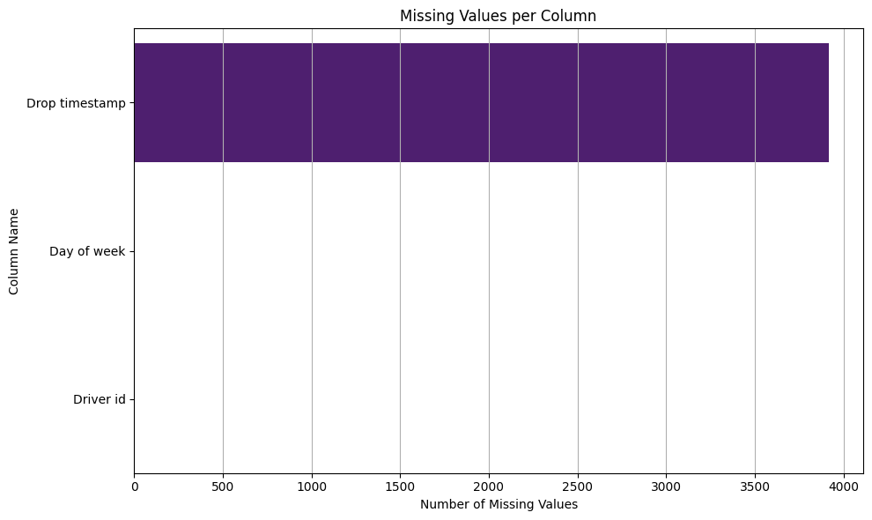

This is the visualization of missing values.

CHART 1 OUTPUT

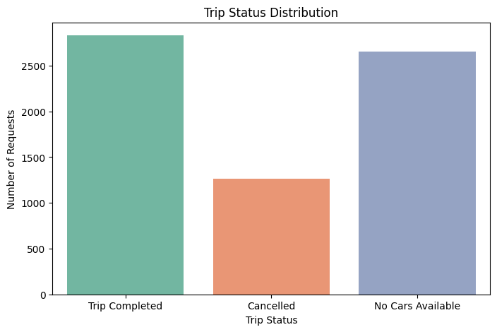  
This the visualization of trip status distribution of Chart 1 output

CHART 2 OUTPUT

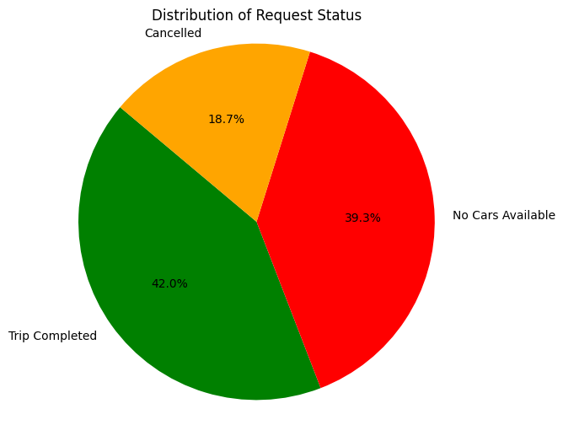

This the output of Chart 2 regarding Distribution of request Status

CHART 3 OUTPUT

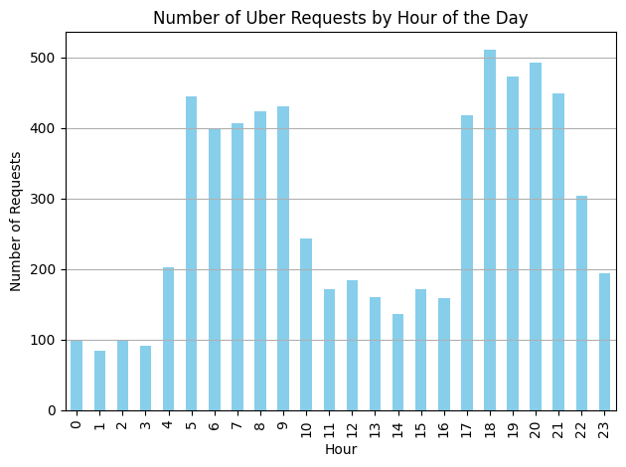

This insight helps improve driver allocation during high-demand hours, enhancing customer experience.

CHART 4 OUTPUT

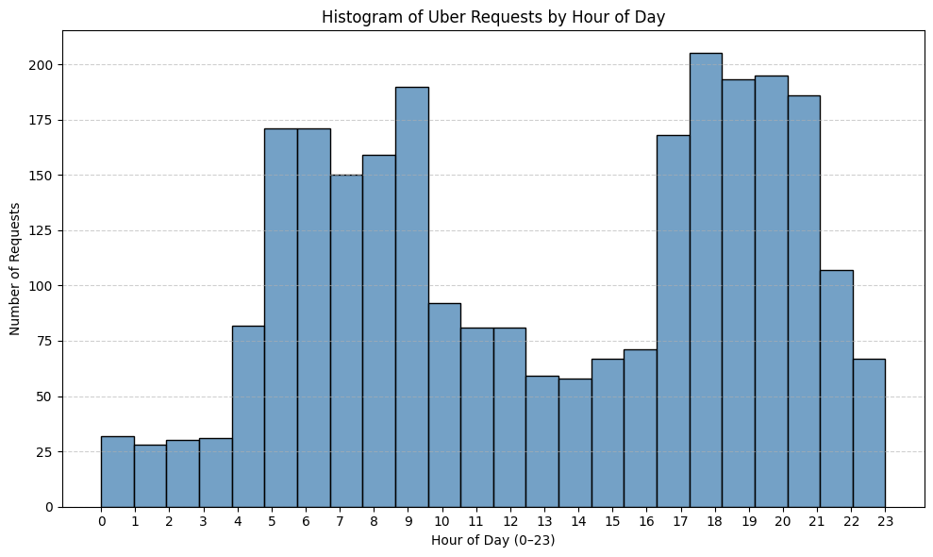

CHART 5 OUTPUT

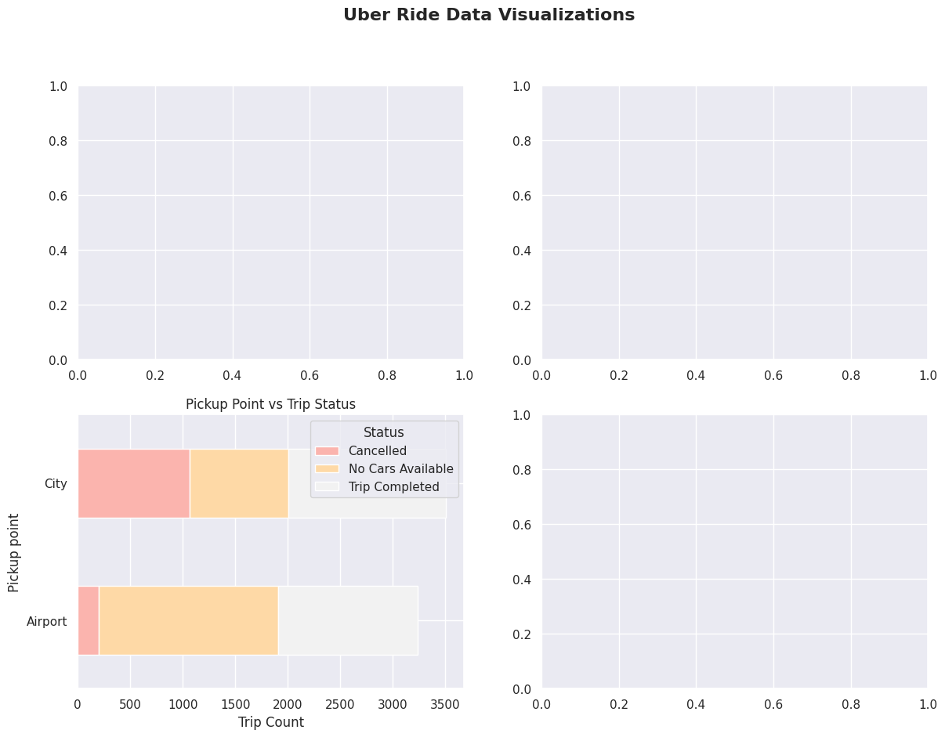

MYSQL

